Dynamic Packaging for Leisure and Business
May 31, 2007

Abstract
Dynamic packaging is both a business model and a technological capability whose time has come. With revenue challenges industry wide, many travel companies are turning to dynamic packaging as a way to sustain or improve margins. The focus has been on the leisure market, but there also are major opportunities in the area of groups and meetings and unmanaged travel and expense (T&E).
This article examines both the business and technology aspects of dynamic packaging and ranks new market opportunities.

Table of contents
Introduction
Product description
Technical analysis
Market insights
Vendor information
References and sources of further information
Glossary

Introduction
The convergence of cheap hardware, inexpensive offshore development, global connectivity, the economic squeeze generated by air carriers/GDSs, consumer demand for quality vacation experiences, and the emergence of the Long Tail have created a market for the selective bundling of travel components into a package on the fly (dynamically, in real time). Most of the dynamic packaging activity is focused on the leisure market, where it is an obvious replacement for/extension of prepackaged tours. But this is only the tip of the iceberg – dynamic packaging also has applications for business travel, groups and meetings and unmanaged T&E. Now that connectivity is becoming ubiquitous and even small players are wired, the huge potential of these markets is within reach.

Product description
Dynamic packaging is the process of bundling travel components that:
- is based on an individual travel arranger’s search request;
- is assembled from multiple travel components in real time; and
- generally provides a single, fully priced package (usually hiding the pricing of individual components)
What dynamic packaging entails
Dynamic packaging has several aspects:
- The needs of the individual travel arranger (client) in terms of destination(s), requirements for air, car or hotel, and other services must be understood. This may involve mid office customer relationship management (CRM) systems that contain passenger profiles or historical purchase history.
- Business logic must be applied to find the content that either directly supports the client’s needs or is part of a campaign to sell additional content. This may involve interpretation of combinability rules based on site policy and/or suppliers’ rules.
- Current availability of content must be determined in near real time.
- Alternatives must be presented to the client with (in many cases) a bundled price for each alternative.
The sale is just the first part. Post-sale activities can include:
- credit card or other form of payment clearance;
- confirmation of reservations with each of the suppliers providing services in the bundle;
- integration with back office functions;
- disbursing funds to the services suppliers;
- maintaining the integrated trip or package record [super passenger name record (superPNR)];
- managing adds, changes and deletes, including airline schedule changes; and/or
- integration with mid office CRM systems.
Content
Clearly content is critical. There are several ways that dynamic packagers provision content:
Airlines: If the source is a GDS, much, but not all, of the air content is already aggregated.
- GDSs must either query airlines directly for availability (as good as it can get) or depend on cached availability (room for error) or airline-reported availability (room for more error).
- GDSs may not have charter or low-cost carrier content, requiring other approaches to get real-time schedules and availability.
Hotels: Getting real-time availability for a broad number of options through an aggregator is difficult. The GDSs and hotel switches have a two-tiered system, stored availability that could be several days old that is often used for shopping, and real time availability for most properties for the final booking process. The problem is that for general hotel shopping, in the Internet age, consumers may want to look at all of the hotel options. This often involves looking at over 100 listings. To get real-time availability for these listings during the shopping process requires substantial computing resources. If the dynamic package is to use a finite number of choices (e.g., six hotels for destination X), then the shopping is less complex and real-time availability during shopping is feasible.
Cars: If the car rental company has real-time connectivity, availability is not a significant issue. There are a relatively small number of car rental companies.
Other content: This may be leisure activities (e.g., horseback riding, day tours) business activities (e.g., airport parking, event tickets, business dinners) or other requests (e.g., meeting rooms, catering). Access to this content is challenging in that while there are some Open Travel Alliance data standards, they are not complete or consistently implemented. While accessing this other content is most difficult, this may be where the most opportunity exists.
Dynamic packaging and the merchant model
The merchant model is a wholesale arrangement wherein suppliers provide content with net charges and business rules to intermediaries who mark up the price and sell the content at retail levels. Several years ago, when hotels had excess capacity and were still defining their distribution strategies, they were more than happy to wholesale rooms. This led to the success of Hotels.com and Expedia, among others, early adopters of the merchant model. In many cases, however, the brand was exposed, causing brand dilution. This resulted in the major chains focusing on their distribution strategies and instituting lowest price guarantees on their Web sites – substantially reducing the amount of available merchant model content.
With dynamic packaging, the process is similar (net rates with business rules), but with a package price the hotel rates are opaque, preventing brand dilution and preserving low price guarantees. This makes dynamic packaging an ideal vehicle for hoteliers (and other travel service providers) to sell distressed inventory. In addition, dynamic packagers are able to mark up merchant content in packages considerably higher (25-35%) than traditional merchant model sales (18-25%). [ST1]
Dynamic packager’s responsibility
The business that sells the dynamic package is the merchant of record and assumes all of the associated responsibility. This involves more than collecting the money, making the reservations and (e-)mailing brochures to the customer. Adds, changes and deletes require extra staff and attention.
In the U.K., to protect travelers, the Package Travel Regulations were legislated in 1992. These make the seller of packaged travel responsible to ensure that the services delivered on a holiday were substantially the same as or better than those represented to and contracted for by the buyer. This can include repatriation in the case where a tour operator goes out of business while the traveler is away from home. To ensure this protection is in place, packagers are required to have an Air Travel Organizer’s License (ATOL) which requires posting a bond with the Civil Aviation Authority. This places a substantial burden on tour companies.
In a recent case, the (U.K.) Court of Appeals determined that dynamically created packages did not necessarily fall under the Package Travel Regulations legislation. This has led to a substantial increase in travel agency plans to offer dynamic packages in 2007. [TW1]
Markup
With the demise of commissions and reductions in airline segment fees, many travel agencies are looking to dynamic packaging as the next money maker.
Margins on hotel merchant content (discussed above) can increase by 7-10%, and Viator (a global provisioner of leisure content) estimates that agencies can expect an average of 16% margin on its leisure content.
Amadeus, which is conducting a dynamic packaging evaluation with Area Travel Agency and Finland Travel Bureau, two of Finland's three largest travel agencies, expects that dynamic packaging will increase agency revenues by 30%. [AM1]

Technical analysis
Conceptual architecture
Conceptually, the technical architecture to support dynamic packaging is similar to other platforms that support travel distribution. The major difference is the extensive use of rules engines similar to those used to support online business travel systems to enforce corporate policy. At one time, only major travel agencies and GDSs could afford systems of this size and complexity, but with open source software, commodity hardware, offshore development and universal connectivity via the Internet, these systems are within the reach of smaller agencies and other travel companies such as airlines. Figure 1 shows the conceptual tiers: presentation, business logic, services and connectivity.
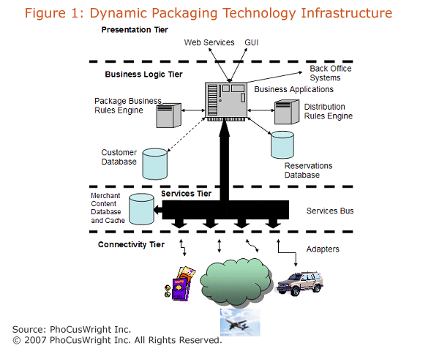
Presentation tier
This is where the interfaces for consumers, travel agents, partner sites, application service provider (ASP) users, and repackagers are provided. End users will require a branded graphical user interface (GUI). While a simple GUI is straightforward, dynamic packages are complex products and work best with the sophisticated presentation and interaction capabilities provided by Flash or Ajax (see The PhoCusWright GDX article, “Customizing the User Experience: Is the Travel Industry Ready?”). For private label users such as travel agencies that want to retain their own brand, there needs to be a white label GUI and customization toolkit.
For those users that intend to reuse the dynamically packaged content with their own GUI, a programmer’s interface using XML and either SOAP or REST (for more information, see The PhoCusWright GDX article, “Travel 2.0, Web 2.0, Services and Silver Bullets”) should be employed.
Business logic tier
This is where all of the value is produced. The business applications take input from the presentation tier and return package alternatives based on:
- the rules governing the construction of packages;
- the rules prescribed by suppliers that govern the distribution and packaging of their content; and
- optionally, the customer database that contains the profiles and preferences of the shopper and/or similar shoppers.
This tier contains the logic for shopping, booking, clearing the form of payment, recording the sale, reserving with suppliers and connecting with the back office. It uses the reservations database to record the reservation, business details and contact dialog in a superPNR. Content that is presented to the shopper is delivered through the services tier, from a local merchant content database, cache of online inventory or a direct connect to online inventory.
The customer database, in addition to storing profile(s) (a traveler may have multiple profiles depending on circumstances: business/leisure, with/without family) and recorded preferences, can be the repository for observed behavior. In advanced shopping sites, users’ behavior could be observed and modeled with profile and preference information to allow a suggestive content model. Put simply, by observing and recording behavior, it is possible to determine the content to be presented that has the highest likelihood of being purchased. There are complex mathematical models that support this capability, and improvements are ongoing. [IN1]
Services tier
This is the delivery mechanism that channels content from multiple sources, both internal and external, to the business logic tier. It generally uses standard XML as its internal language and isolates the business logic tier from differences in workflows, terminology, technology or speed of response that may be characteristic of different suppliers.
The internal sources of content can be either merchant inventory or cached content to facilitate shopping.
Connectivity tier
Connectivity can be through a variety of communications protocols, even on the Internet. This is in addition to differences in:
- Workflow: Some sites may take 10 messages to complete a booking while others may take 20.
- Language: The preferred language is XML in English but other countries may prefer to use their national language. While the Open Travel Alliance has gone a long way to standardize XML, there are many forms of content where standards do not exist. Some, such as Rearden Commerce, are developing defacto standards.
- API: An increasing number of suppliers have Web Services interfaces, but some use SOAP while others use REST, and there are some who still use Edifact.
Because of these differences, the connectivity layer contains a library of custom adapters to provide for the myriad connectivity options.
Web Services, despite challenges with universal interoperability, are an important building block of the Semantic Web (see The PhoCusWright GDX article “Social Networks and the Future World Wide Web”). In a Web 3.0 world, in addition to standard Web Services interfaces, content will be defined semantically so that it is machine readable. This will allow development of systems that build dynamic packages without the explicit, site-by-site programming currently required for the library of custom adapters illustrated in Figure 1.

Market insights
Overall perspective - leisure dynamic packaging
Static vacation packages have never been big in the U.S. market. They have, however, been significant in Europe, and to a lesser extent in APAC. That said, dynamic packaging, presumably because of the promise of high margins, has taken off in the U.S. In Europe, the uptake has been slow but indications are that the growth, particularly in the U.K., will be substantial in 2007 and beyond. APAC has little to no visible activity except in Australia.
U.S.
Figure 2 shows online package growth (leisure/unmanaged business) in the U.S. between 2004 and 2006 with projections through 2008. This is compared to overall packaged tour growth for the same segment. Online packages show healthy growth while the traditional vacation package market is almost flat.
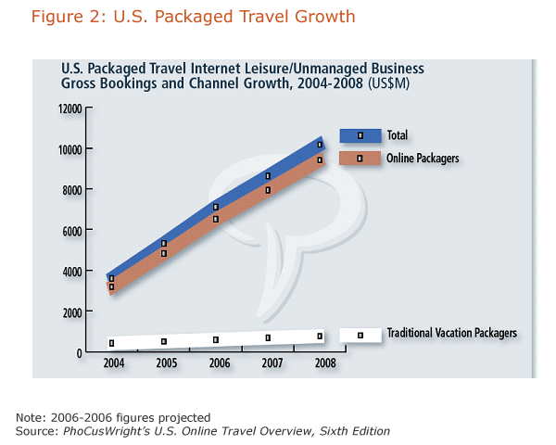
While the online packaging market is significant and growing, it still represents a relatively small percentage of the total market.
EMEA
The primary dynamic packaging activity in EMEA is in the U.K. It appears that the intersection of available technology, reduction of segment fees and ability to avoid the requirements of the Packaged Travel Regulations have created a wave of activity. The following are snippets that provide anecdotal evidence of the activity:
- 1.5 million holidays in the U.K. were dynamically packaged last year [2006] by summer, according to a survey by Thomas Cook. Holiday Brokers estimated that 1.7 million were packaged between January and October 2006, up from 900,000 for the same booking period in 2005.
- 38% of Freedom Group’s business was dynamically packaged last year, with 17,000 bookings made by the end of last summer, compared with 8,000 during the whole of 2005. £45 million turnover and 2,000 passengers in its first year was the target accommodation-only supplier Youtravel.com set for itself at launch last October. Six months later it is right on target, with 95% of bookings coming from the trade. [TW1]
APAC
A prerequisite for the success of dynamic packaging is adoption of online travel. Except for Australia, the market readiness to support online travel in other APAC areas (see Figure 3) is still developing. The next areas of growth for online travel purchases appear to be Japan and India. Once consumers are comfortable with simple trips, more complex bookings such as dynamic packages will follow, but this will take some time.
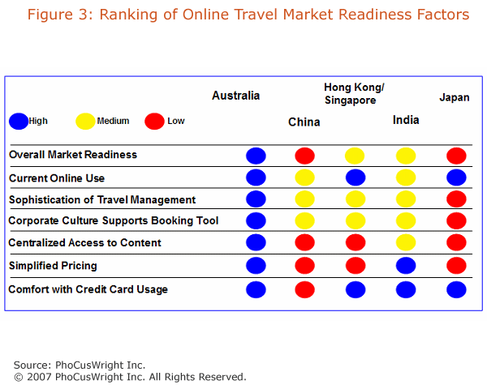

Business travel and unmanaged T&E expense
Rearden Commerce has introduced new capabilities that allow the booking and management of what were traditionally considered unmanaged T&E expenses. These include reservations for car service, event tickets, dining reservations, airport parking and online conferencing. They have integrated content from disparate sources seamlessly in the presentation layer to enhance the user experience.
Rearden claims that these unmanaged expenses amount to as much (and sometimes more) than the managed expenses (see Figure 4)
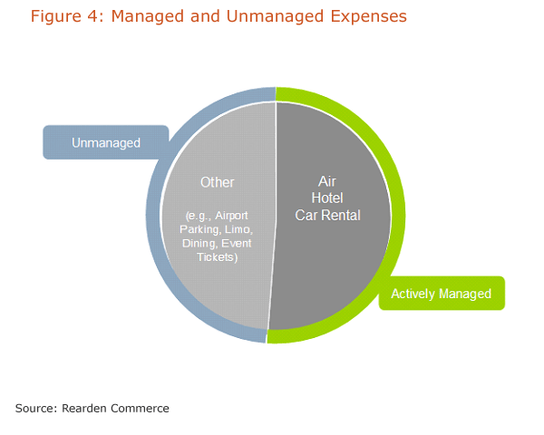
In addition to providing the capability to easily make reservations, Rearden has used its market power to obtain corporate discounts for its growing list of clients. The Rearden platform provides the normal savings one would expect from managed corporate travel plus the opportunity to save 20% or more in the other areas. This, according to Rearden, is in addition to improved productivity of 70-90% in making reservations. The company, which spent five years in stealth mode developing its technology platform, now reports having over 40 TMC partners and more than 400 corporate customers.
Since this approach does not hide the pricing of individual components, and because such things as dining are not paid for in advance, it could be argued that this is not a true dynamic package. It is, however, based on a single request and is constructed in real time, making this a special case of dynamic packaging.
Groups and Meetings
Groups and meetings represent a very large market, approaching $175 billion in 2008. The sector includes such things as: Family reunions, weddings, corporate incentive trips, group business travel, sports team travel, religious retreats and class reunions. This market is substantially underserved in terms of online capability.
Figure 5 shows the online sites that serve this market. None of them provide the full spectrum of content (including such things as: air, hotel, car rental, ground transportation, meeting space, food and beverage, audio visual or entertainment).
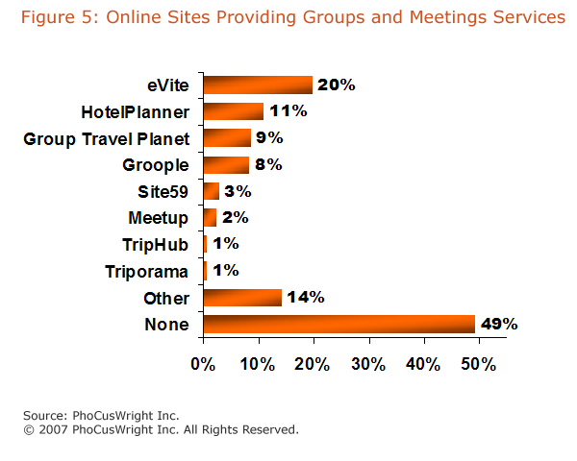
As with unmanaged T&E, it could be argued that this does not constitute a package, but given the size of the market and the fact that it involves multiple components that can be assembled by a single planner in real time and may or may not hide the price of individual components, it should be viewed as another special case of dynamic packaging.
Comparison of opportunities
Leisure dynamic packaging
In the U.S. and the U.K., this market is maturing rapidly, served by a number of large players as well as smaller ones due to the availability of relatively low-cost enabling technology. The large agencies have the resources to implement world-class platforms while the smaller players are using commercial systems or third party services.
Online dynamic packaging has become a natural evolution of a marketplace where online travel purchasing is well established. In these geographic areas, there is a relatively low risk of non-acceptance, but, since there is already substantial activity, lower net opportunity.
Unmanaged T&E expense
This is a new concept with only one major player, Rearden Commerce, which presented a strong enough value proposition for American Express to purchase a 10% stake in the company. The market uptake appears to be solid, but the overall market remains to be sized, and the ultimate percentage of consumer uptake is up in the air, representing a substantial risk. On the other hand, there is a significant opportunity to add content to support the business traveler.
Since this is a new space, there is room for new entrants, but because of the lack of market size information and the uncertainty of uptake, there is a fair amount of risk. Because Rearden spent five years developing its technology platform, new entrants will need to play catchup. The opportunity, however, could be substantial.
Groups and meetings
This is a huge market in the United States alone. It could easily be proportionally as large in other countries where there is substantial online travel penetration. In fact, the majority of the online sites that support groups and meetings are far from being full service suppliers, and most major players do not appear to have made a move in this area (Hilton and Starwood are the exception). The PhoCusWright report Groups and Meetings: Market Opportunity Redefined highlights the characteristics that planners would like to see in a group travel planning site.
The number of large players in this market remains small, leaving the door open for new entrants. Offerings could either be bundled with a TMC online booking product, presented as a stand alone consumer offering, or both. The potential of this dual approach to the marketplace reduces the risk. This segment has only moderate risk but high potential.
The Long Tail
All of these dynamic packaging opportunities could incorporate non-traditional content, part of the travel industry’s Long Tail, making such products readily available to online travel distribution (see The PhoCusWright GDX article “The Long Tail”).
Figure 6 shows some of the potential of the Long Tail.
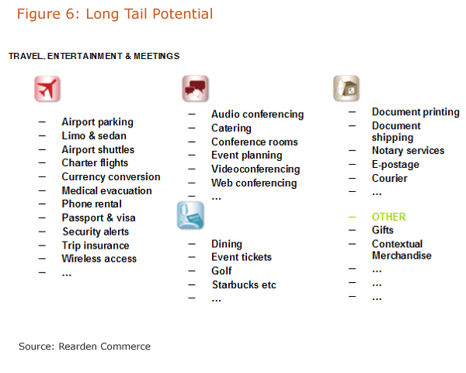
Who are the likely players?
Airlines are a good fit for many of these opportunities, though few (Czech Airlines being a pioneer) seem to have pursued it. With their loyalty programs, high Web site traffic (particularly in the U.S.), world class yield management, extensive technology infrastructure, the need to move inventory opaquely, and the fact that air travel is a component of all the opportunities discussed above, airlines would appear to be a natural fit.
Hotels represent a substantial part of the spend for dynamic packages. In the groups and meetings arena, the percentage of each dollar spent for accommodations is 30% vs. 23% for air. Hoteliers also have yield management tools, online presence, loyalty programs and the need to move opaque inventory, making hotels another good fit.
Online travel agencies have had dynamic packaging engines for some time but have concentrated primarily on the leisure market. The focus has been on air, car and hotel, with some destination add-ons. It is not clear how far they will move out of this comfort zone.
All of the GDSs except Worldspan have some form of dynamic packaging engine. Travelport has the technology it obtained when it purchased Neat Group, which it has deployed on its consumer-facing platforms. Amadeus is conducting its dynamic packaging evaluation in Finland, and Sabre has implemented Trip Tailor, a wholesale dynamic packaging site for travel agencies. These three approaches provide travel agencies with the core technology for dynamic packaging. The key will be the depth and breadth of content that they are able to access and distribute effectively.
The large travel marketing companies are investing in new platforms (building their own or in cooperation with companies such as Rearden or G2 SwitchWorks) that perform many of the same content aggregation functions that GDSs traditionally have, only with new technology and a different business perspective. They have the incentive and the technology to be major players in dynamic packaging.
In Europe, the tour operators are making substantial investments in dynamic packaging, primarily in leisure. To date, they have not had the perspective and interest to move into the corporate and groups and meetings arenas.
Finally, niche players will surface, including smaller tour operators, cruise companies dynamically packaging shore excursions and hotels packaging destination opportunities.

Vendor information
Accovia
Accovia's Selling System Platform with dynamic Pricing Rule Engine can display and discount component prices individually or cumulatively, proffering a single reference price.
Blue Sky Travel Systems
itour Travel Distribution Suite is a reservations module incorporating control processes for all owned inventory and a generic XML interface supporting access to third party inventories, including GDSs, net fares, low cost carriers, charter flights, car rental and more.
Comtec
Comtec Travelink provides live availability searching for holiday packages and travel essentials via a tailored user environment. Travelink is designed to support phone, viewdata, e-mail and Web site reservations of all types of travel product. Pre-packaged, dynamically packaged holidays and travel essentials can be searched, with all booking and enquiries exported to a back-office module.
Datalex
A platformed service-orientated architecture which enables: integration and ease of interoperability with central reservations systems (CRSs), back office systems and other enterprise systems such as content management systems and dynamic multi-source procurement for air, hotel, car, insurance and activities.
Entee Global Services
WebRes-DP is designed to allow multiple travel components, including flights, ferries and accommodation, to be combined into a single dynamic real-time package. WebRes-DP is an integrated real-time travel packaging tool designed for use by direct users, travel trade partners and transportation operators.
Flexible Trips
A travel agency resource site that provides the capability for travel agents to book dynamic packages without having to host the technology.
Hypertech Solutions
Allows travel agents and tour operators to create, price and distribute various packages, from escorted and niche tours to holidays. It is designed to offer multiple destination packages with alternative modes of transportation between cities.
The Neat Group (Part of Orbitz Worldwide)
NeatAgent is the first merchant model application tailored specifically for traditional travel agencies. Using NeatAgent, travel agents create customized packages for their clients, including combinations of air, hotel and car rental. In addition, agents can set their own mark-up that is included in the total package price, and receive payment of the markup automatically through Airlines Reporting Corporation (ARC).
OpenJaw Technology
Provides an XML standards-based platform for delivering dynamic packaging solutions, with connectivity to multiple inventory sources for air, car, hotel and other travel inventory, while also providing the capability to combine travel components into packages based on business rules.
Soft Voyage
The Travel System (TTS) provides both dynamic and static travel packaging capabilities. The inventory management and reservation modules allow tour operators to create and sell extensive a-la-carte or pre-packaged products and features by destination, region or tour.
TravelTek
Combining all the major low-cost airlines and both city and beach-based hotel suppliers into one single search, HolidayMaker allows either agents or consumers to package these together, compare prices to pick out the best deal or edit the pricing on the fly. The company will soon offer dynamic packaging with cruises, flights and hotels all in a single transaction.
Trisept Solutions
Trisept Solutions' dynamic packaging technology offers a shopping cart-based vacation builder that allows comparison shopping between packages that can include airline tickets, hotel rooms, rental cars, insurance, attraction tickets, as well as other elements of a trip.

References and sources of further information
[AM1] “Amadeus Launches Next-Generation Leisure Travel Solution” (Oct. 31, 2006), Amadeus Press Release
“Evaluating Role of Technology in Evolvement from Web 2.0 to Travel 3.0:” www.eyefortravel.com/index.asp?news=55675
[IN1] Interfaces (Jan. 2007), Vol. 37, Issue 1, pp. 68-81
“A Review of the Package Travel, Package Holidays & Package Tours Regulations 1992 –The Consumer Perspective:” www.holidaytravelwatch.net
[ST1] Starkov, Max and Jason Price (March 2005). “The End of the Merchant Model as We Know It:” www.hospitalitynet.org/news/4022589.html
[TW1] Travel Weekly Dynamic Packaging Supplement 2006: www.travelweekly.co.uk/Articles/2006/04/27/21811/dynamic-packaging-supplement-2006.html
[VA1] Viator Dynamic Packaging: http://www.dynamic.viator.com/

Glossary
Ajax: Asynchronous Java Script and XML.
APAC: Asia-Pacific region.
ASP: (Application service provider). Operates software at its data center, which customers access online under a service contract.
ATOL: Air travel organizer’s license.
AVS: Availability status.
CRM: Customer Relationship Management.
Edifact: Electronic Data Interchange for Administration Commerce and Transport.
EMEA: Europe, Middle East and Africa.
Flash: Refers both to browser “plugin” runtime environment and the rich multimedia development environment developed by Macromedia.
GDS: Global Distribution System.
GUI: Graphical User Interface.
OTA: Open Travel Alliance.
PNR: Passenger Name Record.
REST: Representational State Transfer.
Semantic Web: Extension of the World Wide Web in which Web content is available both as natural language and in a form that can be readily understood by other computers.
SOAP: Simple Object Access Protocol.
superPNR: A PNR containing more information than a legacy PNR.
T&E: Travel and expenses.
XML: Extensible Markup Language.
By Bob Offutt

